Database Systems Final Project

Mobile Phone Store

**Team Members:**

* Ivan Ezechial Suratno 2101693920 <http://2101693920ivan.blog.binusian.org/>
* David Honasan 2101693933 <http://2101693933david.blog.binusian.org/>

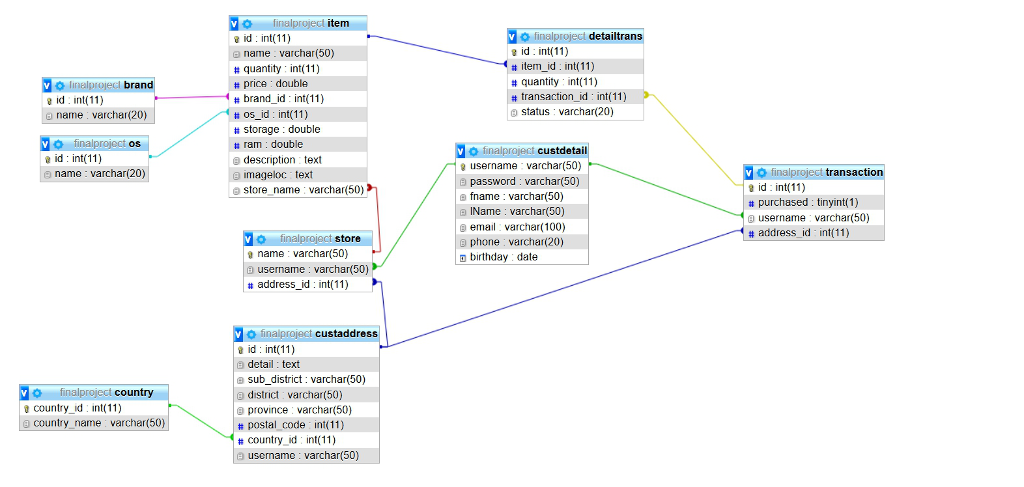**Database Entity-Relationship (ER) Model:**

**Relational Schema:**

* **Brand** (ID, name)  
  **PRIMARY KEY** ID **AUTO_INCREMENT**
* **OS** (ID, Name)  
  **PRIMARY KEY** ID **AUTO_INCREMENT**
* **Item** (ID, Name, qty, price, Brand_ID, OS_ID, storage, RAM, desc, imgloc, storeName)  
  **PRIMARY KEY** ID **AUTO_INCREMENT  
  FOREIGN KEY** Brand_ID **REFERENCES** Brand(ID)  
  **FOREIGN KEY** OS_ID **REFERENCES** OS(ID)  
  **FOREIGN KEY** storeName **REFERENCES** Store(name)
* **DetailTrans** (ID, Item_ID, qty, Trans_ID, status)  
  **PRIMARY KEY** ID **AUTO_INCREMENT   
  FOREIGN KEY** Item_ID **REFERENCES** Item(ID)  
  **FOREIGN KEY** Trans_ID **REFERENCES** Transaction(ID)
* **Transaction** (ID, Purchased, username, address_ID)  
  **PRIMARY KEY** ID **AUTO_INCREMENT   
  FOREIGN KEY** username **REFERENCES** CustDetail(username)  
  **FOREIGN KEY** address_ID **REFERENCES** CustAddress(ID)
* **CustDetail** (username, pass, fName, lName, email, phone, birthday)  
  **PRIMARY KEY** username
* **Store** (name, username, address_ID)  
  **PRIMARY KEY** name  
  **FOREIGN KEY** address_ID **REFERENCES** CustAddress(ID)
* **CustAddress** (ID, detail, subDistrict, District, Province, postalCode, countryID, username)  
  **PRIMARY KEY** ID **AUTO_INCREMENT**  
  **FOREIGN KEY** country_ID **REFERENCES** Country(countryID)
* **Country** (countryID, countryName)  
  **PRIMARY KEY** countryID **AUTO_INCREMENT**